March 27, 2021
Saturday
Timings : 11:50 p.m.- 2:00 p.m.
T


Poetry Reading with Verse of Silence

(Online Event)

Verse of Silence
  - Let’s get creative

Poetry Reading with Verse of Silence is a new initiative by the organization to revive the same old literary tradition of sharing of poetry among peers. This is an online event.

EVENT FLOW –

- Joining in of audience – 11:50 a.m.
- Event Begins- 12:00 p.m.
- Introducing Megha Rao and Kavya Sharma
- One on one discussion between Kavya Sharma and Megha Rao – 12:05 p.m.- 12:50 p.m.
- Welcoming Poetry Reading Judge Madhura Banerjee –
- Poetry Readings by top 10 select poets – 1:00 p.m.
- Final Words
- Event Ends- 2:00 p.m.

Verse of Silence
“Made weak by time and fate, but strong in will

To strive, to seek, to find, and not to yield.”

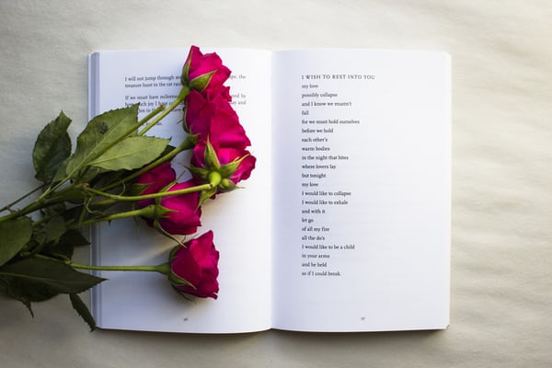
Ulysses, Alfred Lord Tennyson

About the Event
Poetry Reading with Verse of Silence is a new initiative by Verse of Silence wherein we seek to go back to the good old literary tradition of reading poetry. While the pandemic has hit the world hard, we want to use art and artists to heal and grow as a community.

This will be an online event which will begin by a one on one discussion between Kavya Sharma and Megha Rao on Post Modern Poetry and its relevance in today’s time. Last 10 minutes will be given for Q&A with the audience.

After this will see top 10 select poets reading their poetry online in front of a live audience. Our esteemed judge Madhura Banerjee will be selecting 1 winner who will win cash prize of Rs 2K, surprise goodie by Verse of Silence, Winner’s Certificate and story publication in the Verse of Silence Magazine.

The Total Event Duration would be around 2 hours.
.12:00 p.m.- 12:50 p.m.

One on one discussion between Megha Rao and Kavya Sharma
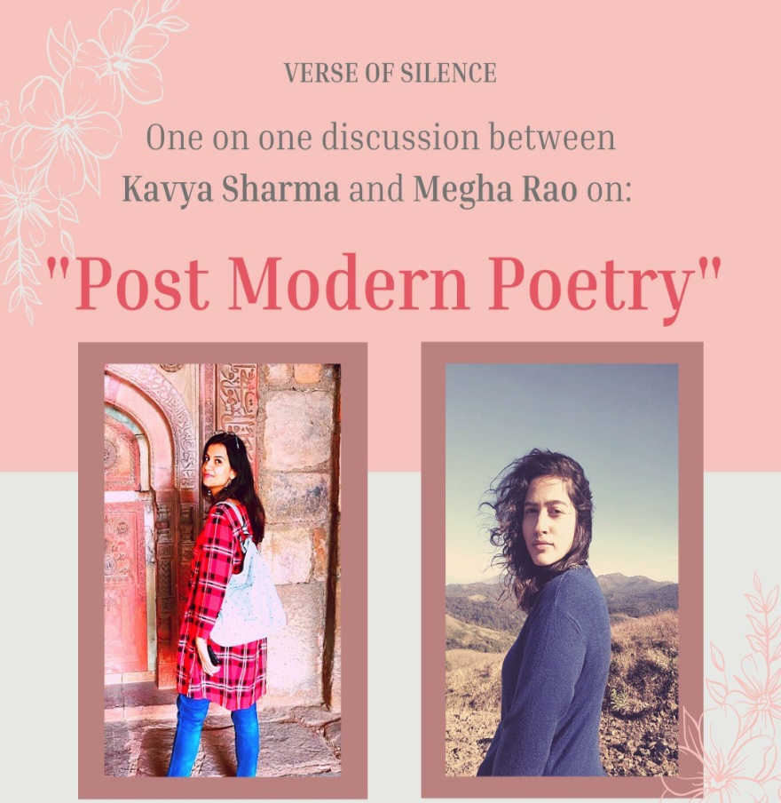
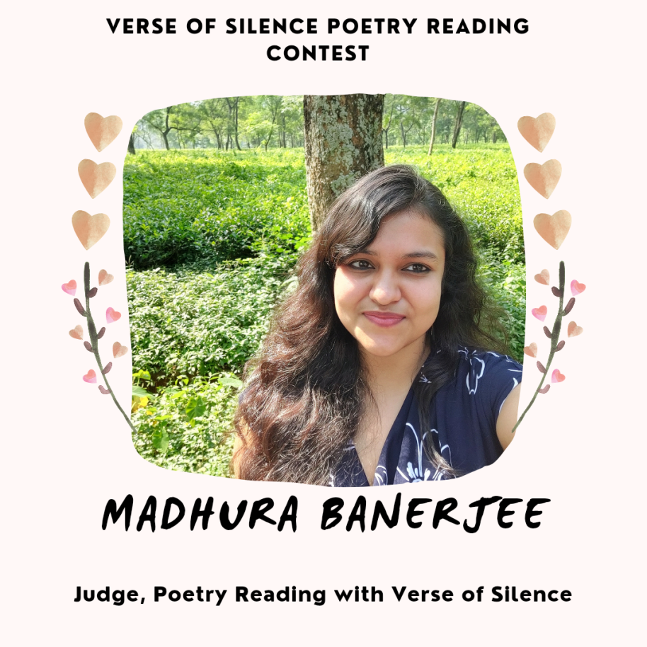

Poetry Reading with Verse of Silence

1:00 p.m. - 2:00 p.m.

You can register for this event by clicking on the link below-

Once you register, you will get a joining link on your email few days before the event.

Registration for the event is open till 22nd March 2021.

Registration Link-
https://imjo.in/zKPDJW
Looking Forward to seeing you at this event!

Lots of love and chai,
Team Verse of Silence
www.verseofsilence.com







